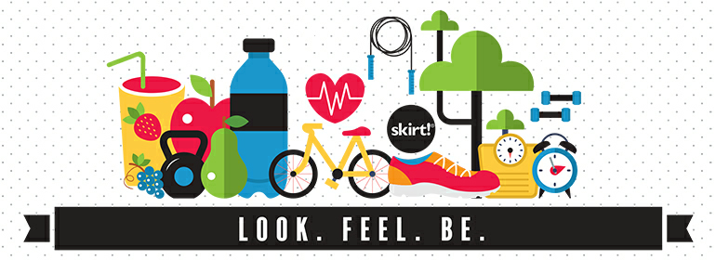

**Nutrition World**

Nowadays, tons of complex issues are facing our

generation due to obesity and not being in shape and the results are disasters like :

Giving up dreams, Bullying about our shape , Health problems and Being low self-esteemed .

We can’t just stand still doing nothing towards that so How about Keeping in Shape?! We believe that if you will, you can!!   
A journey from “… One Day” to “Day One …” can start now.

**Authoring**

Here’s your place if you’re trying to be in shape again ... Imagine a lot of articles, videos, recipes, motivating stories, daily exercises and much more in one place. Track yours :

By having an account, you can keep in touch with all the daily updates concerning diet programs, recommendations about food that suit you and your body and tracking your progress.

# Weight Loss : Wondering how to lose weight? Our weight loss tips, diet plans, videos, and success stories are the tools and motivation you need to make it happen.

# Calorie Control:

You can check how much calories your body needs daily, and you’ll have information about a large variety of foods and brands, and see nutrition facts such as calories, fat, protein, carbohydrates, fiber and sugar.